## Instructions

The first step in the interview process for the VPGAME AI Project Machine Learning Researcher/Engineer position is to choose one of the following topics and submit a solution. If you have questions about the problem definition, if you feel like you need clarification, please send mail to [gan_bing@vpgame.cn](mailto:gan_bing@vpgame.cn) or [shimakaze@vpesports.com](mailto:shimakaze@vpesports.com). When you have a solution you're happy with, send that solution along with a current resume to [hr-us@vpgame.cn](mailto:hr-us@vpgame.cn) or [joinus@vpesports.com](mailto:joinus@vpesports.com).

## Why AI RESEARCH in GAMES?*

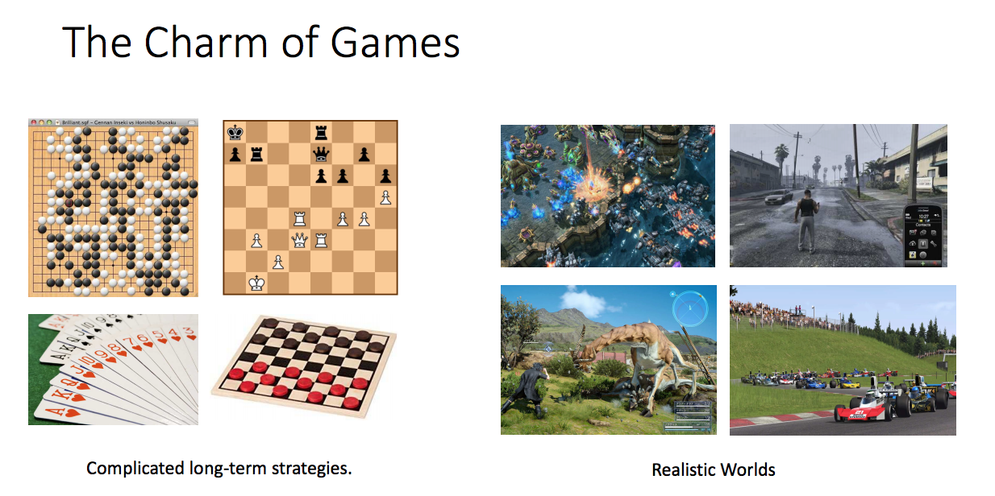

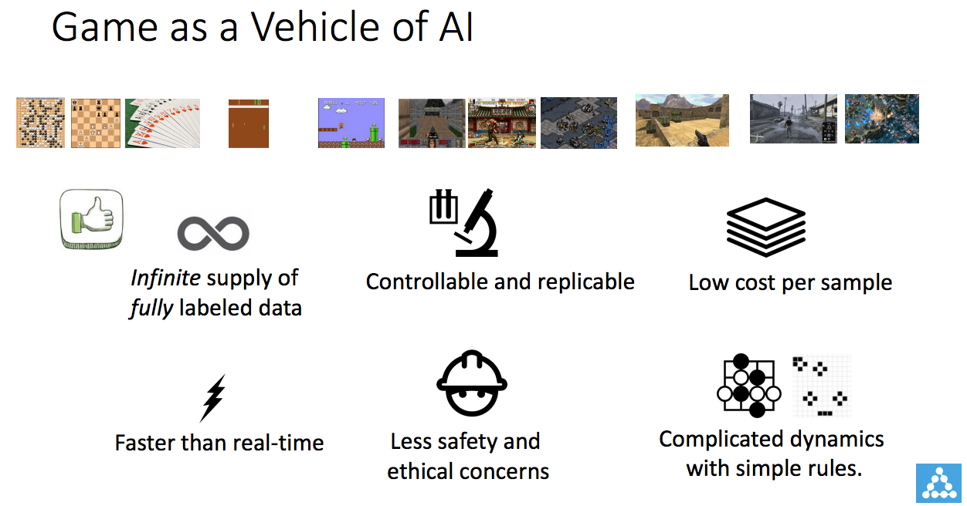

## Topics

1. **Game Result Analyze  
   If you are to analyze who’s the best player of a game, how would you build and train your model?**  
   Training data you will have:  
   10 million history game data including the following information:
   1. player IDs
   2. players’ heroes
   3. players’ stats
   4. result of the match
2. **Game Result Prediction  
   If you are to predict who will win the game, how would you build and train your model? You can choose any one of the following time to predict the game:**
   1. At the start of the game:
      1. Input: 10 players’ IDs
   2. After every player pick their hero:
      1. Input: 10 players’ IDs and their relative hero
   3. During the game:
      1. Input: 10 players’ IDs, their relative heroes, game info up till current time t (this may include scoreboard change with time, team resource change with time, etc.)

The training data you will have:  
 10 million history game data including the following information:

1. player IDs
2. players’ heroes
3. players’ stats
4. result of the match
5. scoreboard record
6. team resource change record
7. **President (card game) AI  
   If you want to train an AI to be able to play President (a card game). How would you build and train your model?**  
   You can find rules about President here:  
   <https://en.wikipedia.org/wiki/President_(card_game)>

## FAQ

**Q: I feel it’s hard to show my solution and great ideas on paper.  
A: You can schedule an appointment with us at** [**hr-us@vpgame.cn**](mailto:hr-us@vpgame.cn) **and we are happy to listen your idea! Any time will work!**

**Q: I think I need more data features to train, is it possible?**

**A: Sure! You can always ask Bing** [**gan_bing@vpgame.cn**](mailto:gan_bing@vpgame.cn) **for more available features**

**Q: Is there any test data that I can play with?  
A: Yes we do have some test data available. You can download it from:**<http://usa.vpgame.com/tempo_storm/700_learning_data_2.pickle>

This is one day’s Dota2 matches record (599868 matches) earlier this year. We trained our model based on 30 days data like this and it worked pretty well. It’s a Python Pickle file and you can decode it by Unpickle it. The format of the data will be like this:  
f_name = '700_learning_data_2.pickle'

with open(f_name, 'rb') as f:

t = pickle.Unpickler(f)

result = t.load()

len(result) = 5 len(result[0])=599868

result[0]: Team1’s hero IDs of 599868 matches

result[1]: Team0’s hero IDs of 599868 matches

result[2]: Team1’s player stats of 599868 matches

result[3]: Team0’s player stats of 599868 matches

result[4]: Match result of 599868 matches with format (Team ID that won the game, duration of the game)

And here is a data of one example match:

result[0][0] - Team1’s hero IDs: [23, 35, 2, 57, 58]

result[1][0] - Team0’s hero IDs: [4, 99, 62, 44, 74]

result[2][0] - Team1’s player stats: [[2, 1, 8, 4, 1346, 28, 2, 190, 196, 3350, 4347, 0, 0, 1533], [23, 2, 11, 4, 872, 40, 0, 267, 329, 5505, 7889, 0, 0, 1533], [35, 3, 8, 4, 168, 61, 15, 253, 340, 4885, 12414, 516, 0, 1533], [57, 2, 8, 2, 31, 27, 7, 211, 235, 5280, 7958, 27, 2631, 1533], [58, 2, 6, 4, 881, 73, 1, 344, 378, 7650, 5814, 0, 169, 1533]]

result[3][0] - Team0’s player stats: [[4, 6, 5, 11, 2457, 128, 0, 546, 449, 13975, 12888, 4036, 266, 1533], [74, 8, 4, 5, 499, 118, 5, 583, 696, 14445, 12716, 2403, 0, 1533], [44, 11, 1, 7, 1685, 125, 18, 618, 606, 14400, 21221, 6698, 631, 1533], [62, 6, 2, 17, 3248, 19, 2, 494, 426, 9650, 7221, 1188, 1825, 1533], [99, 10, 2, 11, 216, 108, 6, 532, 518, 15600, 19621, 1398, 0, 1533]]

result[4][0] - Result: [0, 1533] # Team 0 wins the game and the total game tile is 1533 seconds.

## What To Send Us

Here's what you'll send to [hr-us@vpgame.cn](mailto:hr-us@vpgame.cn) or [joinus@vpesports.com](mailto:joinus@vpesports.com)

* A current resume
* A discussion (a few paragraphs) about the possible solutions you see to the problem and why you chose the approach you did.
* If you need to schedule an appointment with us, send your available time slots.